REALIGN: GROUP 1 (Katie)
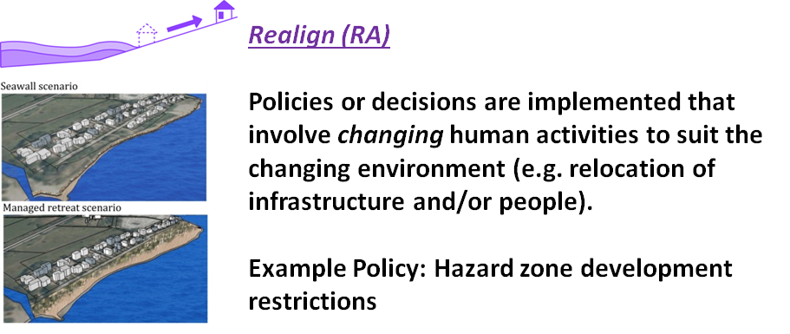
- STRATEGIES or POLICIES: What can communities do to REALIGN away from hazards? (e.g. zoning restrictions)
- METRICS: How will communities measure the success of these strategies/policies? (e.g. households out of harm’s way)
- HOW TO PAY FOR THESE POLICES/STRATEGIES: Who and how will policies/strategies be funded? (e.g. raise taxes, grants)
- WHO NEEDS TO BE INVOLVED: Who in the community needs to be involved in the development of these strategies/policies? (e.g. decision-makers, specific community

Strategies or Policies | Metrics | How to Pay? | Who needs involved?
Construction and/or contractor incentives out of hazard zone (Itchung) | Rate comparison of incentivized communities v non-incentivized. Housing availability and affordability. # of incentives per community. | Utilize vacant properties to save on costs. and? | Coastal Caucus, county commissioners, city planners, economic organization (YBEF)
Incentives for buyback programs. (Maya) |  |  | Coastal caucus, county commissioners, city planners, economic organizations, Local banks, community lenders, town halls, property owners.
Reevaluate value of properties, restore function of property. (coastal land trust model) (Tom) | How much private property at risk of losing value can turn into public property. | Insurance payoffs, subsidy programs, advertise long term savings. | Coastal caucus, county commissioners, city planners, economic organizations. Environmental NGOs (TMC) who manage land trusts.

REALIGN: GROUP 2 (Dylan)
- STRATEGIES or POLICIES: What can communities do to REALIGN away from hazards? (e.g. zoning restrictions)
- METRICS: How will communities measure the success of these strategies/policies? (e.g. households out of harm’s way)
- HOW TO PAY FOR THESE POLICES/STRATEGIES: Who and how will policies/strategies be funded? (e.g. raise taxes, grants)
- WHO NEEDS TO BE INVOLVED: Who in the community needs to be involved in the development of these strategies/policies? (e.g. decision-makers, specific community

Strategies or Policies | Metrics | How to Pay? | Who needs involved?
-Limiting new building in these areas as opposed to realigning  -If something is built in inundation zone, ensure its seismically engineered. | -Number of zoning permits granted for buildings inside/outside of zone;  -Number and type of zoning wavers  - Number of buildings reinforced vs not | Lodging taxes; especially for infrastructure for tourists  Taxes – state level | DLCD
If there was an event, rebuild outside inundation zone | -Number of zoning permits granted for buildings inside/outside of zone; | FEMA relief;  Taxes – state level | DLCD
Hospitals, emergency responders; schools | How far/many are outside inundation zone | Frame taxes such that people inland can benefit from it | - USACE  -Community education/out reach
sewage treatment plants – before event, not after | Town level – number of towns that have plant outside. | Taxes – state level | -USACE  Oregon watershed enhancement board – funded by lottery
Encourage communication between towns for constructing new critical facilities outside of inundation zone |  |  | Seagrant and other grants

PROTECT: GROUP 1 (Jenna)

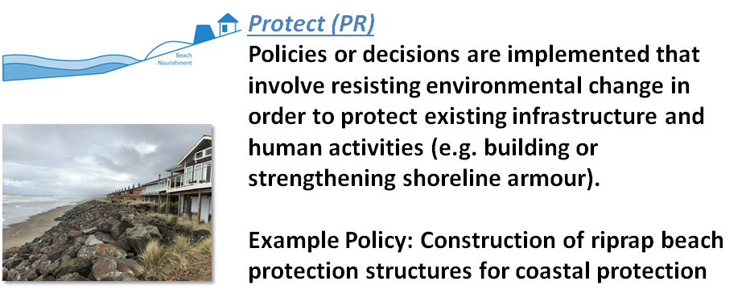

- STRATEGIES or POLICIES: What can communities do to PROTECT themselves from hazards? (e.g. update building codes)
- METRICS: How will communities measure the success of these strategies/policies? (e.g. households out of harm’s way)
- HOW TO PAY FOR THESE POLICES/STRATEGIES: Who and how will policies/strategies be funded? (e.g. raise taxes, grants)
- WHO NEEDS TO BE INVOLVED: Who in the community needs to be involved in the development of these strategies/policies? (e.g. decision-makers, specific community)

Strategies or Policies | Metrics | How to Pay? | Who needs involved?
Armor with GI on property (keep water on property)--local municipalities have GI codes (e.g. x% of impervious surface). | Volume of water leaving the property  10% reduction of BMPs | Cost share mechanism to help pay for GI | Landowners  Local municipalities  County needs to have reinforced county policies—regulatory implementation power.
Habitat native restoration for native oysters; blocks erosion & wave action. Wire cages; Gaybon (oyster shells) | Before and after (experimental design)  Change in erosion  Recruitment of native oysters (depends on habitat—works in the bay) | Solicit funding from grants for restoration | Permitting agencies (if more widely adapted)
Terracing for shellfish gardens (TEK); making clam gardens in inter-tidal lands, good habitat for culturing calms | Recruitment  Physical structure--erosion |  | Tribes  Shellfish hatcheries—providing seeds (also could help with $$)
Comprehensive tailing of critical infrastructure (operating elevation of those systems) | Establish a baseline (subject to impact); how many facilities have you mitigated (pumpfields—waste/drink water); dispersed organizations | Rate payers  State or county resiliency grants | Water districts; utilities
Vertical evacuation structures in areas where evacuation is limited | Multi-use structures (make it efficient—serves a large amount of people)  Location—placement—serves a large amount of people | Lodging tax to support construction costs over time | Local governments, ASCE, researchers
Living levy—horizontal levy that allows for different habitats, slows SLR | Amount of flooding  Maintenance cost

PROTECT: GROUP 2 (Meredith)

- STRATEGIES or POLICIES: What can communities do to PROTECT themselves from hazards? (e.g. update building codes)
- METRICS: How will communities measure the success of these strategies/policies? (e.g. households out of harm’s way)
- HOW TO PAY FOR THESE POLICES/STRATEGIES: Who and how will policies/strategies be funded? (e.g. raise taxes, grants)
- WHO NEEDS TO BE INVOLVED: Who in the community needs to be involved in the development of these strategies/policies? (e.g. decision-makers, specific community
Balancing preparing for acute vs chronic hazards
Policies based on science rather than insurance/ legal battles. Take lessons learned from CA wildfires
Programs to purchase properties for retreat (state agencies buy and then rent back?)
Moving public infrastructure east of 101
Apply these strategies at state rather than county or city level? No one size fits all approach, hard to change goal18, county level adjustments may allow more flexibility

Strategies or Policies | Metrics | How to Pay? | Who needs involved?
Allow natural deterioration – stop protecting
Allowing for more strategic (contiguous) approach armoring – ‘protective regions’
Identify regions of hotspot erosion/ deposition
Prioritize ensuring access to transportation network
Encourage natural/dynamic protective structures

RESTORE: GROUP 1 (John)
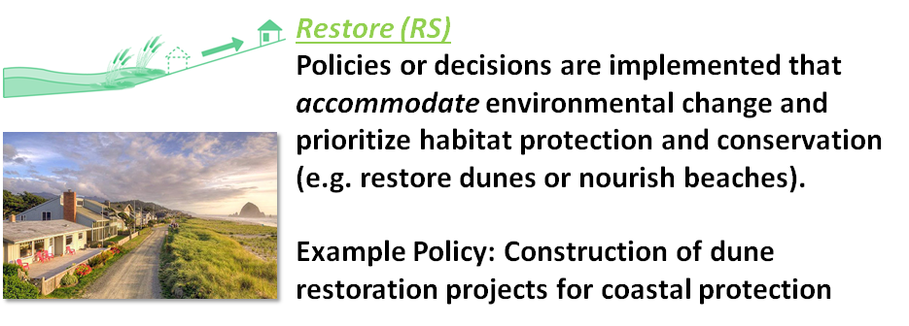

- STRATEGIES or POLICIES: What can communities do to RESTORE natural conditions to mitigate hazard impacts? (e.g. restore dune vegetation)
- METRICS: How will communities measure the success of these strategies/policies? (e.g. households out of harm’s way)
- HOW TO PAY FOR THESE POLICES/STRATEGIES: Who and how will policies/strategies be funded? (e.g. raise taxes, grants)
- WHO NEEDS TO BE INVOLVED: Who in the community needs to be involved in the development of these strategies/policies? (e.g. decision-makers, specific community

Strategies or Policies | Metrics | How to Pay? | Who needs involved?
Land use incentive for private owners – conservation agreements, transferable development rights | Comparative measures between communities with/without programs – National programs may provide models | Tax relief  Payments via market  Public/private partnerships | State involvement in guidance to local communities
State leadership to incentivize local governments
Strong state guidance on land use goals, natural hazards goal specifically, more teeth |  |  | Guidance document from Oregon
Statewide policy not to vacate public land west of 101 (e.g. roads not built but platted)
Public education about hazards, risks; science education | Change of perceptions about risk |  | Extension, other entities? Policymakers, active citizen groups;  Jose Melendez (UO) public education
Beach appropriate assist in public education masks to
Master Naturalist program focused on coastal restoration |  |  | e.g Surfrider, master gardners

RESTORE: GROUP 2 (Peter)

- STRATEGIES or POLICIES: What can communities do to RESTORE natural conditions to mitigate hazard impacts? (e.g. restore dune vegetation)
- METRICS: How will communities measure the success of these strategies/policies? (e.g. households out of harm’s way)
- HOW TO PAY FOR THESE POLICES/STRATEGIES: Who and how will policies/strategies be funded? (e.g. raise taxes, grants)
- WHO NEEDS TO BE INVOLVED: Who in the community needs to be involved in the development of these strategies/policies? (e.g. decision-makers, specific community

Strategies or Policies | Metrics | How to Pay? | Who needs involved?
Better setbacks | # of building impacted by tsunami | Very expensive to nourish beaches | Decision making community
Construct to FEMA elevation standards + elevations high enough to withstand tsunamis | # of building impacted by SLR | taxes | Surfrider other groups that use Oregon’s beaches for many reasons.
Vertical evacuation structures. | % of protected shoreline | Volunteers for planting
Keep spatial data updated! New information on hazards continuously improved and updated. | Increase/decrease in tourism | Community fees
Be open to changing current strategies. | # of volunteer participants involved in restoration | Hotel tax  Grants for implementation of restoration (pew charitable trust).

