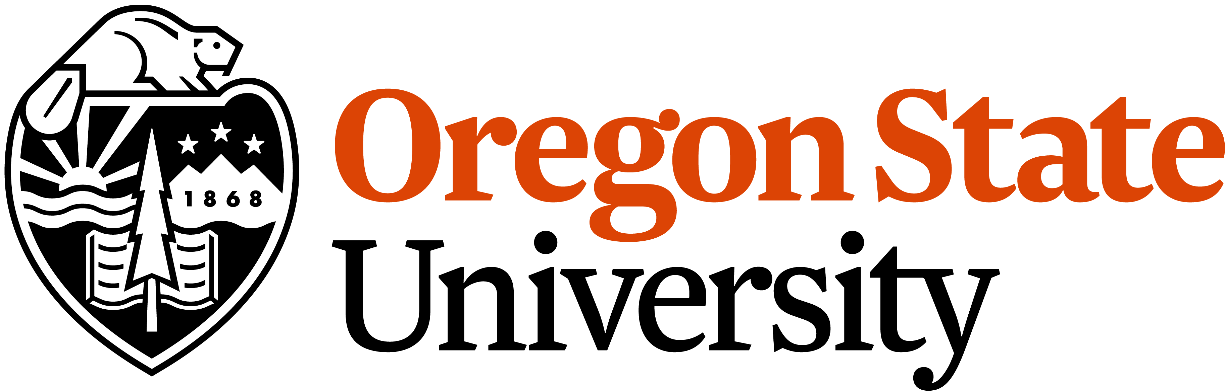 | 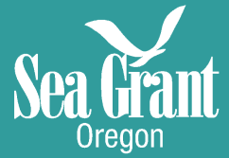

Envisioning a Resilient Oregon Coast: Co-developing alternative futures for adaptation planning and decision-making

Fall 2019 Advisory Council Meeting
12 November 2019 (9:00 am – 12:00 pm, optional lunch from 12:00 pm – 1:00 pm)

Kearney Hall Room 311 (Kearney Library)
Oregon State University
Corvallis, OR 97333

**Parking available in A2 lot across from Kearney Hall. Please see Cindy Olson in Kearney 101 for a complimentary parking pass.

Meeting Objectives:
- Update the Advisory Council on project progress at beginning of year 2.
- Demonstrate initial capabilities of Envision model to facilitate actionable research on hazard planning for Cascadia Subduction Zone earthquake and tsunami.
- Harness the expertise of Advisory Council to develop actionable knowledge to inform statewide policies and localized decision-making.

Agenda:
8:45 - Check-in (Coffee and light snacks provided)
9:00 - Welcome, Introductions, Meeting Overview (Pat)
9:15 - Project overview and progress on items discussed at last AC meeting (Peter)
9:30 - Envision Demo (Dan and John)
10:00 - Discussion (all)
- Equity issues (Jenna and Katy)
- Lifeline analyses (Dan and Dylan)
- Econometrics modeling (Steve and Amila)
- Feedbacks between acute and chronic hazards (Peter and Meredith)
10:55 - Break
11:05 - Short Student Presentations on Project progress
- Forecasting extreme total water levels (Meredith)
- Coastal Economics – information shocks (Amila)
- Distributional Equity of Policy Planning (Katy)
11:30 - Feedback from Advisory Council and articulation of actionable research our project can tackle (Pat)
11:45 - Wrap up/next steps/project timeline (Pat and Peter)

12:00 - Optional Lunch (please RSVP by 11/8 if you plan to attend and with any dietary restrictions)

Project/Meeting Overview:
This is the second bi-annual Advisory Council meetings for the ‘Envisioning a Resilient Oregon Coast: Co-developing alternative futures for adaptation planning and decision-making’ project. Our 3-year project is built on the premise that adaptive capacity for hazard resilience can be realized by examining - and assigning value to - common resilience decisions and their trade-offs at varying scales (communities, counties, and coast-wide). These decisions include questions regarding whether to protect infrastructure with hard engineering backshore protection structures or natural or nature-based features such as dune restoration projects and beach nourishment. Our transdisciplinary research team is developing, applying, and assessing a transferable framework to improve coastal community adaptation and resilience to chronic and acute hazards.

Questions we’d like you to consider:
In the context of coastal community planning for climate change and extreme events,
- What do you care about? In other words, what types of project output, endpoints, or quantified resilience metrics would most benefit your work?
- What coastal policies would you most like to see incorporated into the project’s framework?
- What is a useful planning horizon?
- In this project we plan on adding more econometrics, social equity, and feedbacks between acute and chronic hazards. What else would you like to see us tackle?
- Are there state-level programs or new initiatives in this area that we should be aware of? Do you know of other data sets or models we should be aware of?
- Who else should be on our advisory council/ who should we be talking to?
- Is there anything in the context of this project that you would like answered directly from coastal community members during our interviews and focus groups?
- What else should we be doing to ensure that this work results in actionable knowledge?

Project Team Member Contacts:
Principal Investigators | Email | Expertise
Peter Ruggiero, Lead | pruggier@coas.oregonstate.edu | Coastal Geomorphology/Hazards
John Bolte | John.Bolte@oregonstate.edu | Biological/Ecological Engineering
Pat Corcoran | Patrick.corcoran@oregonstate.edu | Extension Coastal Hazards
Dan Cox | Dan.Cox@oregonstate.edu | Coastal Hazards Engineering
Steve Dundas | Steven.Dundas@oregonstate.edu | Environmental Economist
Jenna Tilt | Jenna.Tilt@oregonstate.edu | Social Science
Students
Meredith Leung | leungmer@oregonstate.edu | CEOAS Graduate Student
Dylan Sanderson | sandersondylan@gmail.com | CCE Graduate Student
Amila Hadziomerspahic | Amila.Hadziomerspahic@oregonstate.edu | AgEcon Graduate Student
Katherine Stanton | stantoka@oregonstate.edu | Anthropology Graduate Student

Call-in/Zoom Option (though we’d prefer it if you were here!):

Ruggiero, Peter is inviting you to a scheduled Zoom meeting.

Topic: Envisioning Oregon's Coastal Futures - Advisory Council Meeting
Time: Nov 12, 2019 09:00 AM Pacific Time (US and Canada)

Join Zoom Meeting
https://oregonstate.zoom.us/j/151521931

Phone Dial-In Information
+1 669 900 6833 US (San Jose)
+1 929 205 6099 US (New York)

Meeting ID: 151 521 931

Join by Polycom/Cisco/Other Room System
151521931@zoomcrc.com

