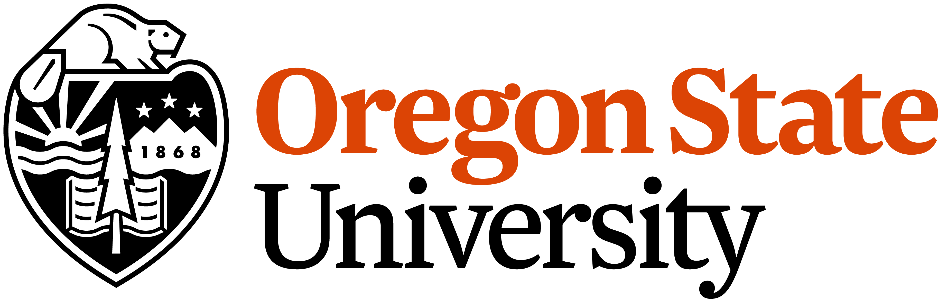 | 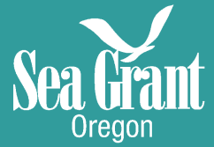

Envisioning a Resilient Oregon Coast: Co-developing alternative futures for adaptation planning and decision-making

Advisory Council Meeting
8 March, 2019 (1:00 pm – 3:00 pm)

Sea Grant Conference Room
1600 SW Western Blvd Ste 350
Corvallis, OR 97333

Meeting Objectives:
- Communicate project goals and set expectations for Advisory Council engagement.
- Begin to harness the networked expertise of key partners and stakeholders to develop actionable knowledge to inform statewide policies and localized decision-making.
- Articulate actionable research that can be conducted effectively with the Envision model.

Agenda:
12:00 -1:00 Optional informal poster session and lunch (opportunity to meet, chat, and eat prior to the meeting)
1:00 Welcome, Introductions, Project Overview (Corcoran)
1:15 OSU presentations and demos with continuous feedback/discussion with Advisory Council
- Overview of Past Envisioning Coastal Futures Projects – focus on Chronic Coastal Hazards (Ruggiero)
- Incorporating Acute Hazards into Envision Framework (Kameshwar, Cox)
- Envision Demo (Bolte)
- Discussion of distributional consequences, social equity, and consistency concerns of coastal adaptation and resilience decisions in Oregon (Tilt)
- Incorporating econometric modeling into Envision framework (Dundas)

2:30 Articulation of actionable research our project can tackle (Corcoran)
2:45 Wrap up and Next Steps (All)

Project/Meeting Overview:
This is the first of approximately bi-annual Advisory Council meetings for the ‘Envisioning a Resilient Oregon Coast: Co-developing alternative futures for adaptation planning and decision-making’ project. Our new 3-year Oregon Sea Grant funded Envisioning a Resilient Oregon Coast project is built on the premise that significant gains towards building adaptive capacity for hazard resilience can be realized by examining - and assigning value to - common resilience decisions and their trade-offs at varying scales (communities, counties, and coast-wide). These decisions include questions regarding whether or not to protect infrastructure with hard engineering backshore protection structures or natural or nature based features such as dune restoration projects and beach nourishment. Our transdisciplinary research team is beginning to develop, apply, and assess a transferable framework to improve coastal community adaptation and resilience to chronic and acute hazards.

Call- in/Webex Option (though we’d prefer it if you were here!):

Envisioning a Resilient Oregon Coast - Advisory Council Meeting
Friday, March 8, 2019
12:45 pm | Pacific Standard Time (San Francisco, GMT-08:00) | 3 hrs
Meeting number (access code): 920 052 468

Link: https://oregonstate.webex.com/oregonstate/j.php?MTID=m76811edd2a0f922aa937fdd9e98ff3cd

Join by phone
+1-415-655-0002 US Toll

Parking Options:
- There are a couple of visitor spaces at the site – first come first serve.
- Metered hourly parking in the B and C lots is the cheaper option, see: https://transportation.oregonstate.edu/parking/maps
- The parking building above the Bookstore is handy. Attendees will have to find a parking place in the correct lot and walk a little ways depending on where they park.
- Other resources:
· Hourly Parking
· Daily parking permits
· Short Term and Visitor Parking Rates
· Visitor ADA Parking

Project Team Member Contacts:
Principal Investigators | Email | Expertise
Peter Ruggiero, Lead | pruggier@coas.oregonstate.edu | Coastal Geomorphology/Hazards
John Bolte | John.Bolte@oregonstate.edu | Biological/Ecological Engineering
Pat Corcoran | Patrick.corcoran@oregonstate.edu | Extension Coastal Hazards
Dan Cox | Dan.Cox@oregonstate.edu | Coastal Hazards Engineering
Steve Dundas | Steven.Dundas@oregonstate.edu | Environmental Economist
Jenna Tilt | Jenna.Tilt@oregonstate.edu | Social Science
Students/Postdocs
Meredith Leung | leungmer@oregonstate.edu | CEOAS Graduate Student
Dylan Sanderson | sandersondylan@gmail.com | CCE Graduate Student
Amila Hadziomerspahic | Amila.Hadziomerspahic@oregonstate.edu | AgEcon Graduate Student
Katherine Stanton | stantoka@oregonstate.edu | CEOAS Graduate Student
Sabarethinam Kameshwar | kameshws@oregonstate.edu | CCE postdoc

